**Using G-Cubed in a Codespace**

## G-Cubed Environment

The G-Cubed model can be run using a Github Codespace. If you don’t already have a GitHub account, please complete the following steps.

* Create a personal account on GitHub.
* Send your GitHub username to FSCC Secretariat (fscc.secretariat@frb.gov).
* After you receive an invite email from the vendor, accept the invite within seven days.

After you are granted the access to G-Cubed, please complete the following steps to set up the computing environment.

* Load home repository - Load “federalreserve.gov-0.1” (<https://github.com/McKibbin-Software-Group>) in browser, which is the G-Cubed home repository for the Federal Reserve Board. Note that the G-Cubed models are maintained in a separate repository, federalreserve.gov-0.1-model. If users use Git to create new branches, they will appear in this separate repository.
* Create a codespace - Navigate to the “Code” tab of the federalreserve.gov-0.1 repository and click on the green “Code” button. This will open a dropdown menu. Click on the “Create codespace on main” option to create a new codespace using the repository. Once the codespace is set up, your browser window will display your VS Code editor. Note that the name of the main branch is *main*.

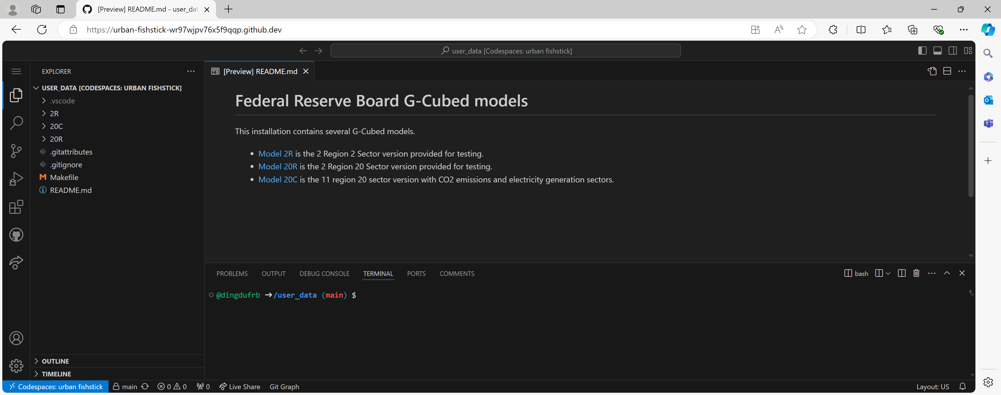

* Create a branch - To create a new branch in Git, you use the git checkout command and add the -b flag with a name. This will create a new branch off of the current branch. The new branch's history will start at the current place of the branch you "branched off of." For instance, the following command will create a new branch, dingdu, off of the main branch.

*git checkout -b dingdu*

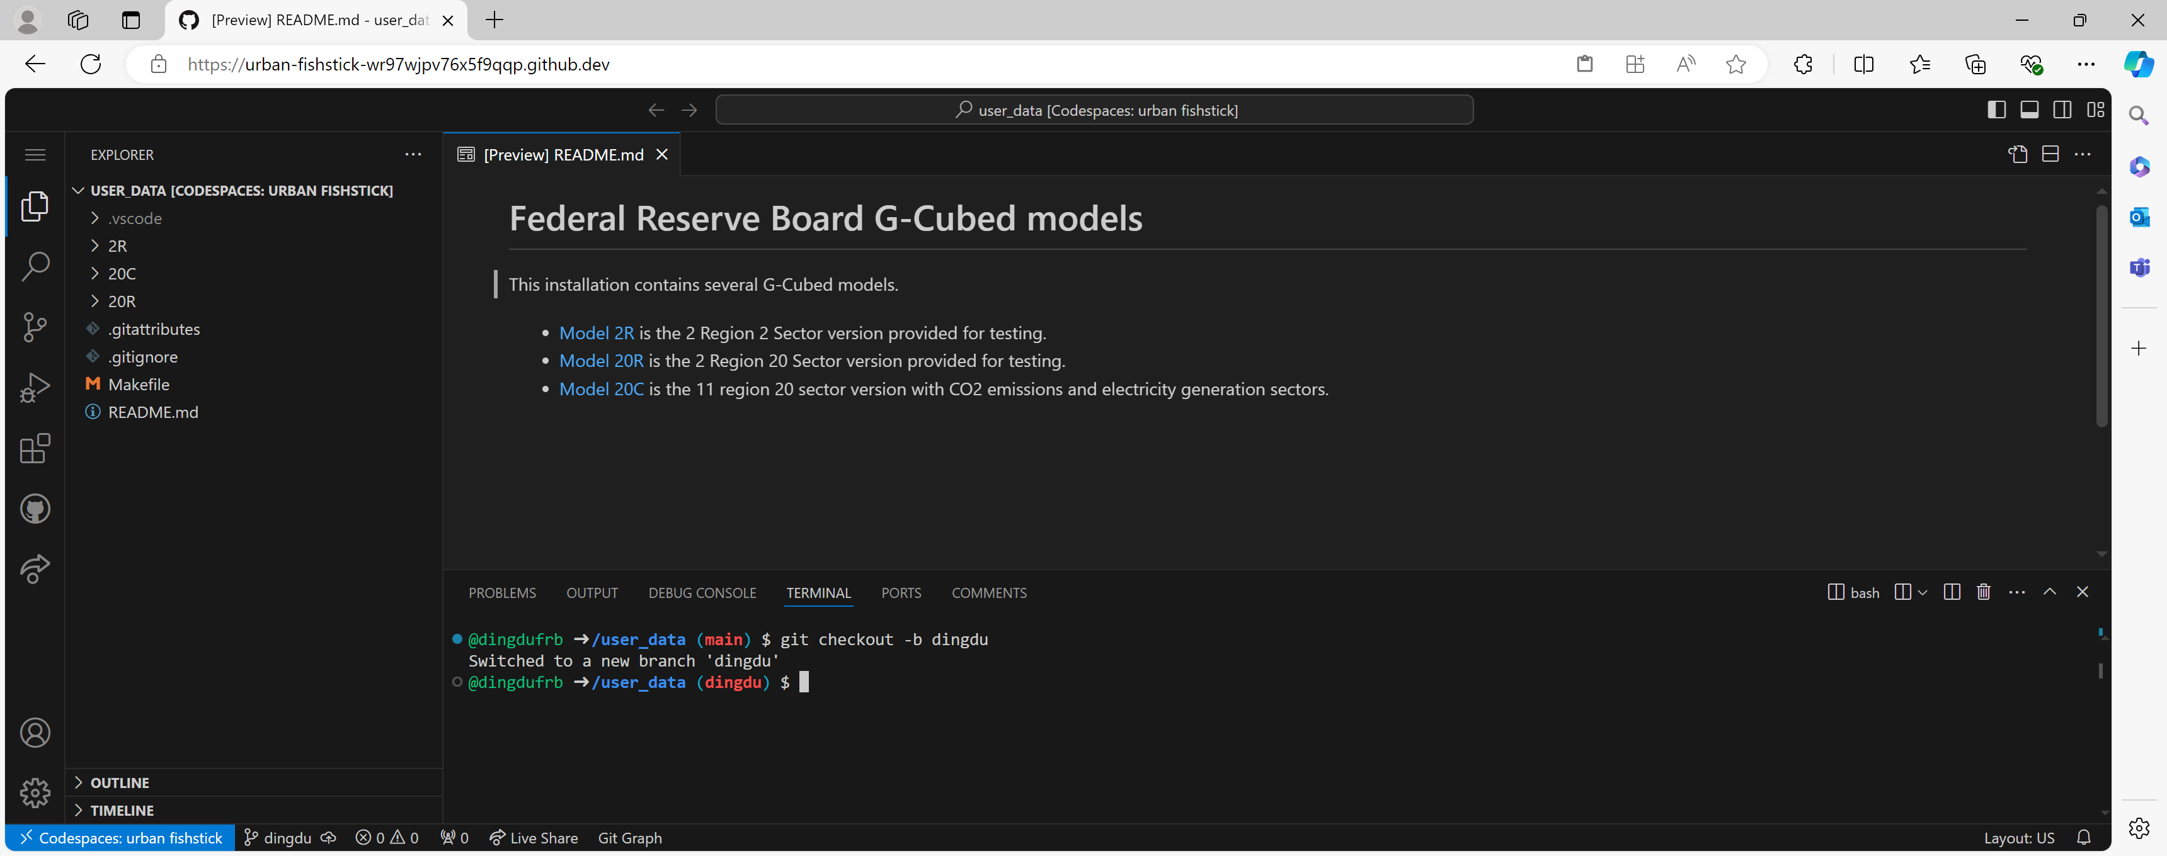

To switch to an existing branch, you use git checkout (without the -b flag) and add the name of the branch that you want to switch to. For instance, the following command will switch to the main branch.

*git checkout main*

When users are finished with the virtual machine, perform the following sequence to ensure that the virtual machine stops:

1. Click the blue-background “Codespaces” button in the bottom left status bar of VSCode to reveal the Codespaces menu.
2. Click the “Stop Current Codespace” item on that Codespaces menu to shut down the virtual machine.
3. Close the browser tab.

Given that there are no Service Level Agreements or availability guarantees, data could be lost because of a hardware failure. As such, users should push their changes to the Github repository, which can be done by using Git add, commit, and push commands. For instance, we change the version from 20C to 20R in Makefile.

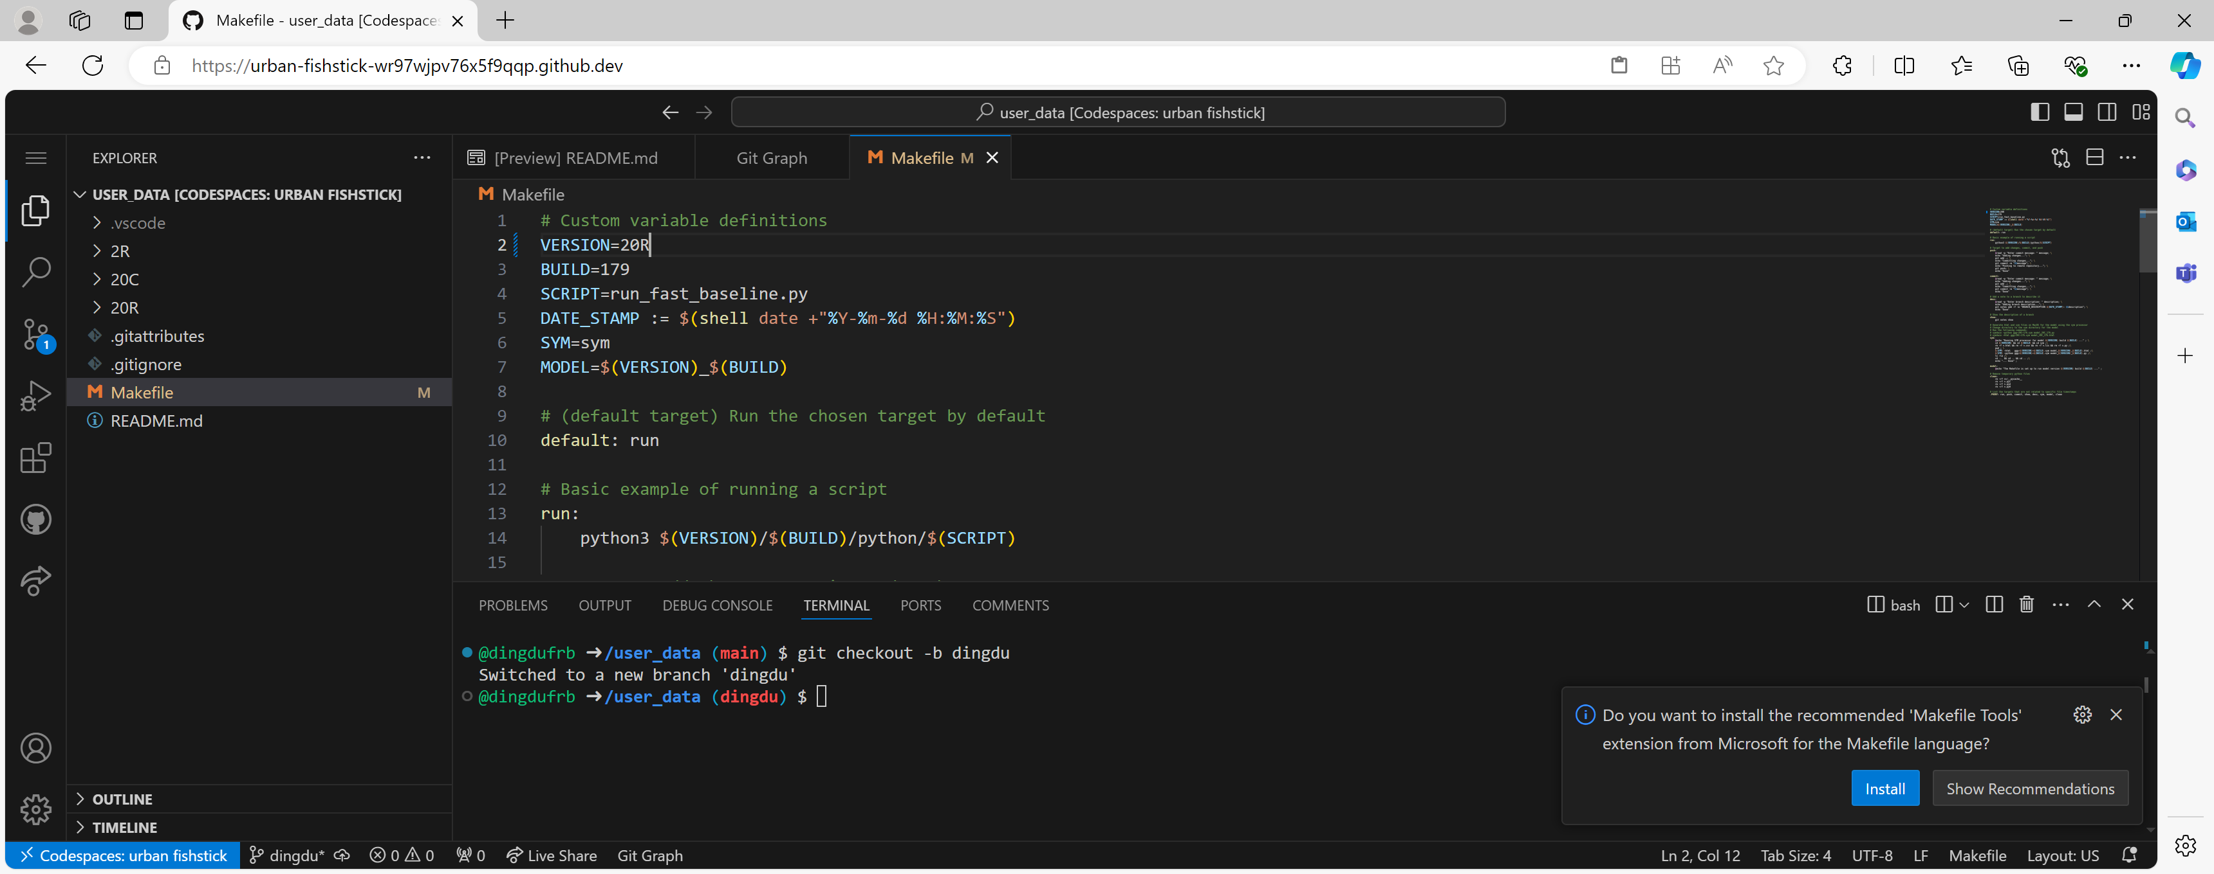

To save the change to GitHub, we use the following commands. First, we prepare the content staged for the commit by using the following command.

*git add .*

Second, we commit the changes with the following command.

*git commit -m “Updated model version”*

Third, we push the changes to GitHub.

*git push*

We may receive an error message, “fatal: The current branch dingdu has no upstream branch.” To set up the upstream branch, we can use the following command.

*git config --global push.autoSetupRemote true*

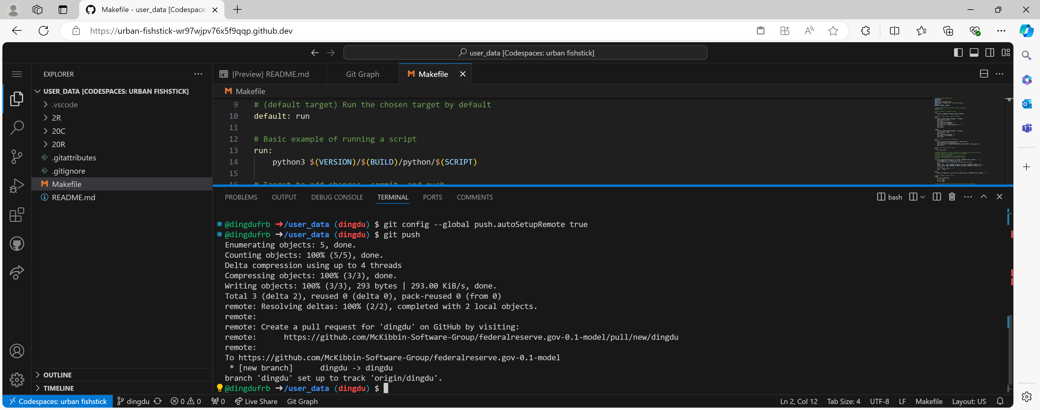

## Model Directory

G-Cubed models are named by “version” and “build”.[1] For instance, the full model in the FRB repository is currently named “20C / 179”.[2] After setting up a G-Cubed environment in a GitHub Codespace, there will be a model directory, “20C/179”, for the full model under “USER_DATA”. Since the model directory structure and the process of running simulations are the same across model versions and builds, we use 20C/179 as our example throughout this document. For other model versions and builds, replace “20C” and “179” with pertinent model version and build.

The model directory contains the model configuration CSV file, configuration20C179.csv, and six subdirectories:

* “chartpacks” contains chartpacks used by the G-Cubed Charts application @ <https://documentation.gcubed.com/>..
* “data” contains the data files used by the model (e.g., database.csv, user_parameters.csv).
* “diagnostics” contains various CSV files that can be used to do diagnosis.
* “python” contains the Python scripts used to run simulation experiments.
* “simulations” contains the CSA files to define simulations.
* “sym” contains the SYM files that define the model (e.g., ggg-main.sym).

A separate directory, “results / 20C / 179”, contains experiment results based on the full model “20C / 179”. This directory will contain a subdirectory for each experiment. The subdirectory is named after the model version, build, and the Python script that implemented the experiment (e.g., results/20C/179/run_fast_experiment_1). All folders have lower-case names. This must not be changed because G-Cubed is case sensitive.

## Running Simulations

1. Define model specificaiton– First, configure and process relevant sym files (e.g., ggg-20C-179.sym, etc.) in the “sym” folder in order to implement the pertinent specification of the model (e.g., the linear specification).**[3]**

* Select linear or log specification by configuring the main sym file, ggg-20C-179.sym, in the “sym” folder. For instance, to select the linear specification, uncomment (i.e., deleting //) the linear model script line, and comment out (i.e., adding //) the log model script line.

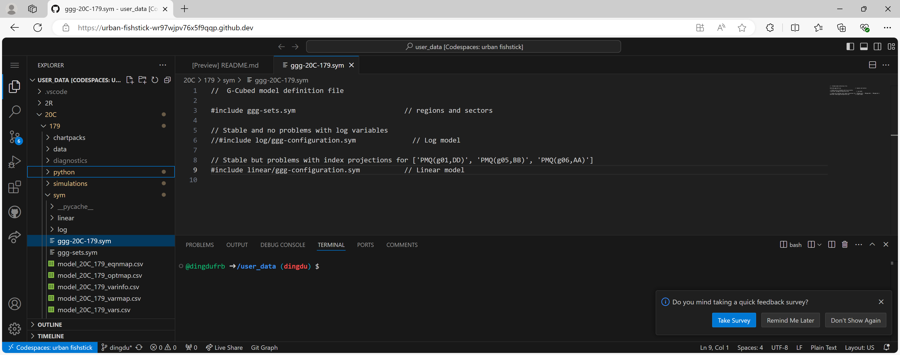

* Select fiscal policy and sector specific taxes modules by configuring the configuration file, ggg.configuration.sym, in the “linear” or “log” subfolder depending on which specification is selected in the step above. For instance, to select “Closure: Deficit determined endogenously while spending is exogenous” for the linear specification, uncomment the pertinent script line (i.e., deleting //) in ggg.configuration.sym within the “linear” subfolder.

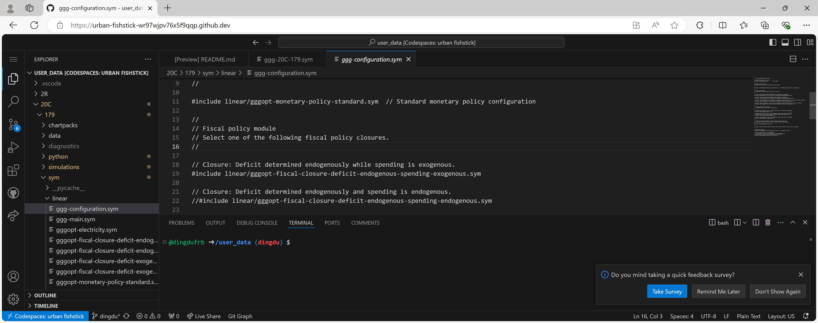

Second, process the SYM files for that model specification by the SYM processor. The SYM processor is always run against the main SYM file, ggg-<VERSION>-<BUILD>.sym..For model 20C build 179, the main SYM file is ggg-20C-179.sym. That SYM file determines how the SYM processor is to find all other SYM files that define the model. It also determines whether the linear or log model is being used. Again, change that setting by commenting out the model that is not needed*.* To process the main sym file,

* Change the directory to the “sym” folder with the cd command.

*cd /user_data/20C/179/sym*

* Process the main sym file with the following sym command.

*sym -python ggg-20C-179.sym model_20C_179.py*

That processing creates:

* a listing of the model sets, parameters, variables and equations in the .lis file
* an implementation of each of the model equations in Python in the .py file
* various CSV files that document model details in a way that is easily loaded when running the G-Cubed model.

The sym processor can also be used to generate HTML documentation of the model with the following command.

*sym -html ggg-20C-179.sym model_20C_179.html*.

**Note that if the model specification is changed, the csv, lis, and py files associated with the prior specification should be deleted before processing the modified sym files (please see below). Do not delete any sym files in the “sym” folder. If you accidently deleted any sym files, you could delete the present Codespace and create a new one.**

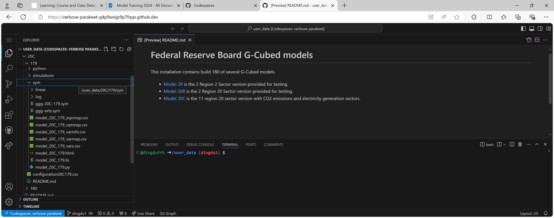

Note that another particularly useful file is ggg-main.sym in the “sym/linear” or “sym/log” subfolder, as the file contains variable and parameter definitions as well as relevant equations. For instance, below is the file for the linear version of the model in the ‘sym/linear” folder.



1. Specify the baseline - Exogenous adjustments to labor-augmenting productivity, population, and autonomous energy efficiency improvements are made to baseline projections in the G-Cubed model. Those exogenous adjustments are compiled into a set of shocks to exogenous variables when the baseline projections are created. That compilation process generates two additional files in the “data” folder, labor_augmenting_technical_change.csv and baseline_exogenous_projections.csv. If you make changes to source data files, these two generated data files will need to be deleted before the model is run again.[4]**If default baseline shocks and projections will be used, this step can be skipped**.

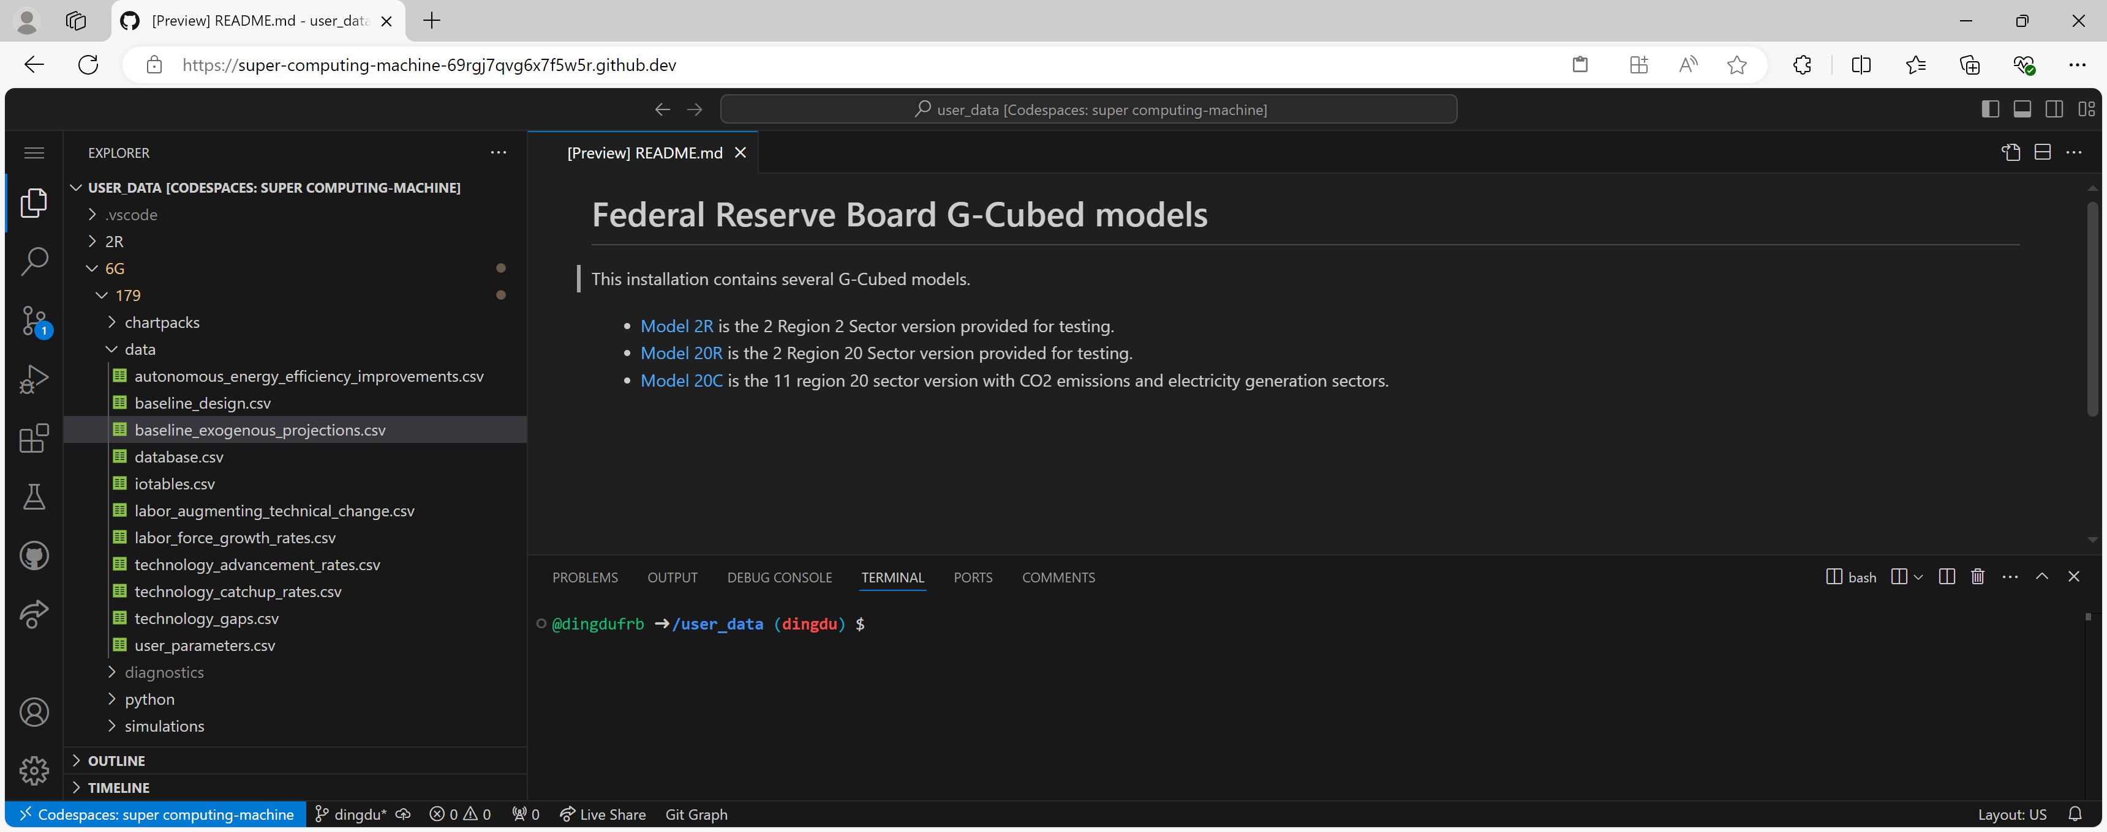

1. Specify the experiment - Create and upload design and adjustment files for simulations to the “simulations” folder. Use the G-Cubed naming conventions for subfolders and files. For instance, a subfolder is usually named “experiment_x” with x representing a specific simulation, and design and adjustment files are usually named as “design.csv” and “adjustments.csv”, respectively. Note that G-Cubed is case sensitive.
2. Create design file – The design file is comma delimited, and the values in the file must not contain commas. The first row of the design file contains column labels. They are, in order:

* name – “name” is used for experiment documentation purpose (e.g., projection files are named based on “name”).
* data - “data” contains the name of the CSV file with the increments to exogenous variables (e.g., adjustments.csv). Note that the data file must not include changes to variables that are not exogenous variables, and that the directory location of the file is assumed to be the same as the directory location of the experiment design file. There must be exactly one CSV file for each simulation layer.
* event_year - The event year must be after the first projection year (2018 in the current G-Cubed configuration file).
* description – It is used for experiment documentation purposes.

Each of the following rows in the design file sets out the definition of a single simulation layer. **Users could download and modify the design file for an example to ensure the compatibility of the file.**

1. Create adjustments file(s) - There must be exactly one CSV file for each simulation layer. The data file is a comma-delimited CSV file. The first column contains the full variable names for the exogenous or state variables that change. The following columns are for the changes to the variables in each year from the simulation layer’s event year through to the last projection year (2150 in the current G-Cubed configuration file). The simulation layer file has column headings in the first row:

* name (for the full name of the variable)
* 2025 (if the event year is 2025)
* 2026
* …
* 2150 (if the last projection year is 2150).

After the column headings row, there is one row for each variable. That row contains the shocks to that variable in each of the simulation layer’s years. The rows for the variables can be in any order. **Users could download and modify the adjustment file for an example to ensure the compatibility of the file.**

1. Create a subfolder in the “simulations” folder for each simulation by right clicking on the “simulations” folder and then on “New Folder…”. Name the subfolder “experiment_x” with x representing the simulation name.

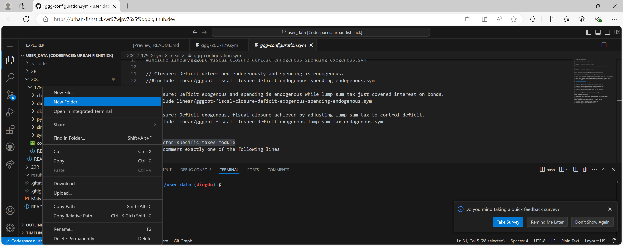

Then upload the design and adjustment files for each simulation to its pertinent subfolder by right clicking on the experiment subfolder and then on “Upload…”.

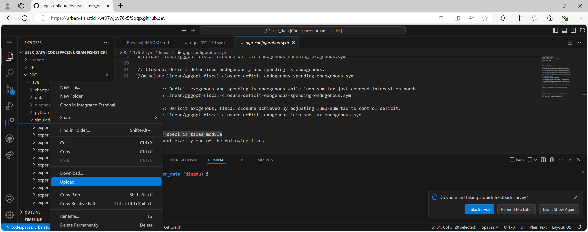

1. Run the experiment – Create, upload, and execute relevant python scripts
2. Create and upload python scripts for simulations to the “python” folder.  **Users could download the python script for an example. For simulations that only involve shocking exogenous variables, users only need to modify the experiment name.** Use the G-Cubed naming convention (e.g., run_fast_experiment_x.py), and upload the scripts to the “simulations” folder.

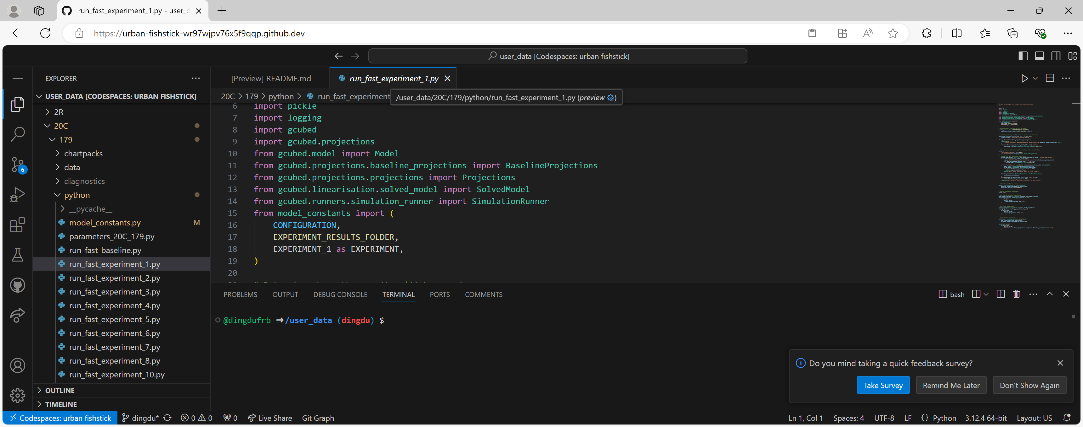

There are two other Python files in the Python directory: the model constants file, model_constants.py, and the model parameter calibration class, parameters_20C_177.py. The parameter calibration class should not be altered except in exceptional circumstances. The model constants file in the “simulations” folder, model_constant.py, can be altered to include new experiment design files as new experiments are created. We will show how to do this in the replication example in the next section.

1. Run “run_fast_baseline.py” in the “python” folder. This creates the “results” folder (user_data/results/20C/179/run_fast_baseline) and to produce the model solution and the baseline projections.[5] These are saved with a pickle extension in the “results” folder. **If a different version of the model (e.g., with a different fiscal policy module) is used or baseline shocks are modified, make sure to delete all of the files in the /results/<VERSION>/<BUILD>/run_fast_baseline folder and re-run “run_fast_baseline.py”.**
2. Run “share_baseline_projections_with_experiments.py” in the “python” folder. This creates separate results directories for all of the experiments defined in model_constants.py (all scripts with a run_ name prefix) and to create symbolic links to the model solution and the baseline projections in each of those directories. Note that when the model solution and baseline are regenerated, the symbolic links to their original versions will automatically update to their new versions. That is, if you rerun the model or baseline, the model solution and the baseline projections in each of those directories will be updated. This is convenient, but it can lead to unexpected changes in results if you are not aware that the model solution and the baseline projections have been updated.
3. Run the script for the experiment of interest. **If only one experiment is being considered (as opposed to multiple experiments), b) and c) above can be skipped**, as the experiment script will generate baseline projections if they are not available yet. **Note that if an experiment is modified, the prior projections should be deleted before the experiment is ran again**.

Users can run an experiment by opening the python file for the experiment in the VS Code editor. A small arrow will appear in the top right corner of the open window. The experiment will run by clicking on that small arrow.

1. Download projections from the “results” folder. **Users can delete the “results” folder after relevant projections csv files are downloaded.** Keeping projections, particularly pickle files, can use up the GitHub storage quickly.

The previous build, 178, can also be run in SALT. Appendix D provides instructions for running G-Cubed models in SALT.

One of the TA’s working on G-Cubed, Charles Knipp, had made a shell on his branch of G-Cubed that helped automate some repetitive commands when working with the model on a regular basis. For more information, please refer to Appendix E.

## A Replication Example

Warwick J. McKibbin presented their study titled “The International Economic Implications of the Trump Program” on September 16, 2024 at the FRB.



One experiment that Warwick’s team ran was a 60-percentage point tariff increase on China (Slides 25 – 32). They found adverse effects on both China and US from this tariff increase.

Inflation

Percentage point deviation for each year

Real GDP

Percentage deviation for each year

|  |  |
| --- | --- |
|  |  |

Although we will replicate this experiment with 6G instead of 20C (as Warwick’s team used 6G), the general process of running a simulation is the same across different model versions.

1. Define model specification – To use the linear version with “Deficit determined endogenously while spending is exogenous”, we turn on relevant options in the main sym file, ggg-6G-179.sym, and the configuration sym file in the “linear” subfolder, ggg-configuration.sym. To select the linear version, uncomment (i.e., deleting //) the linear model script line, and comment out (i.e., adding //) the log model script line.

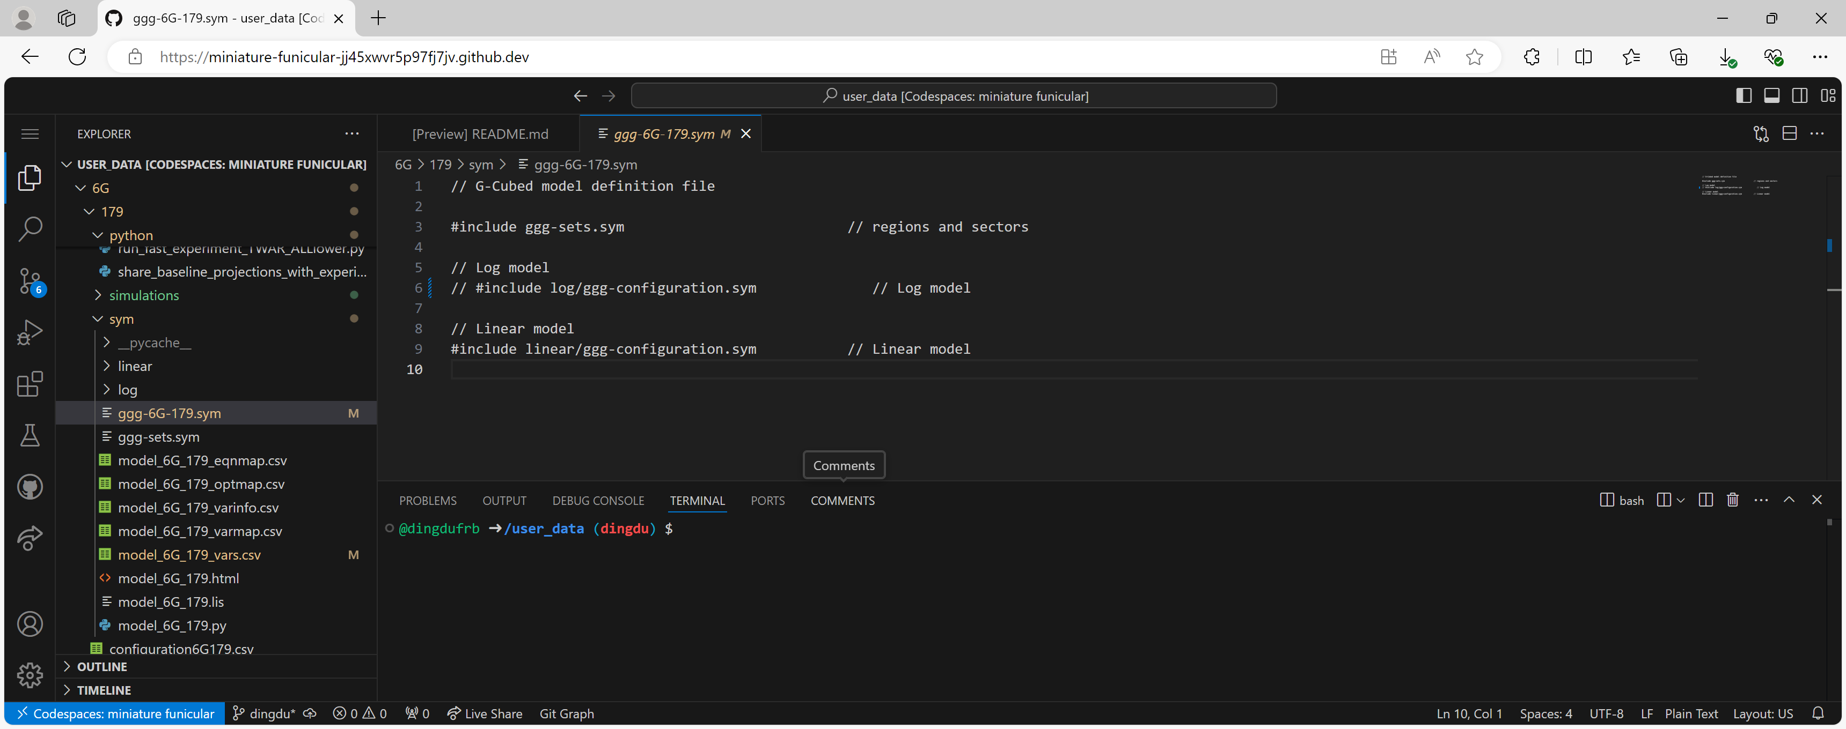

To select “Closure: Deficit determined endogenously while spending is exogenous” for the linear version, uncomment the pertinent script line (i.e., deleting //) in ggg.configuration.sym within the “linear” subfolder.

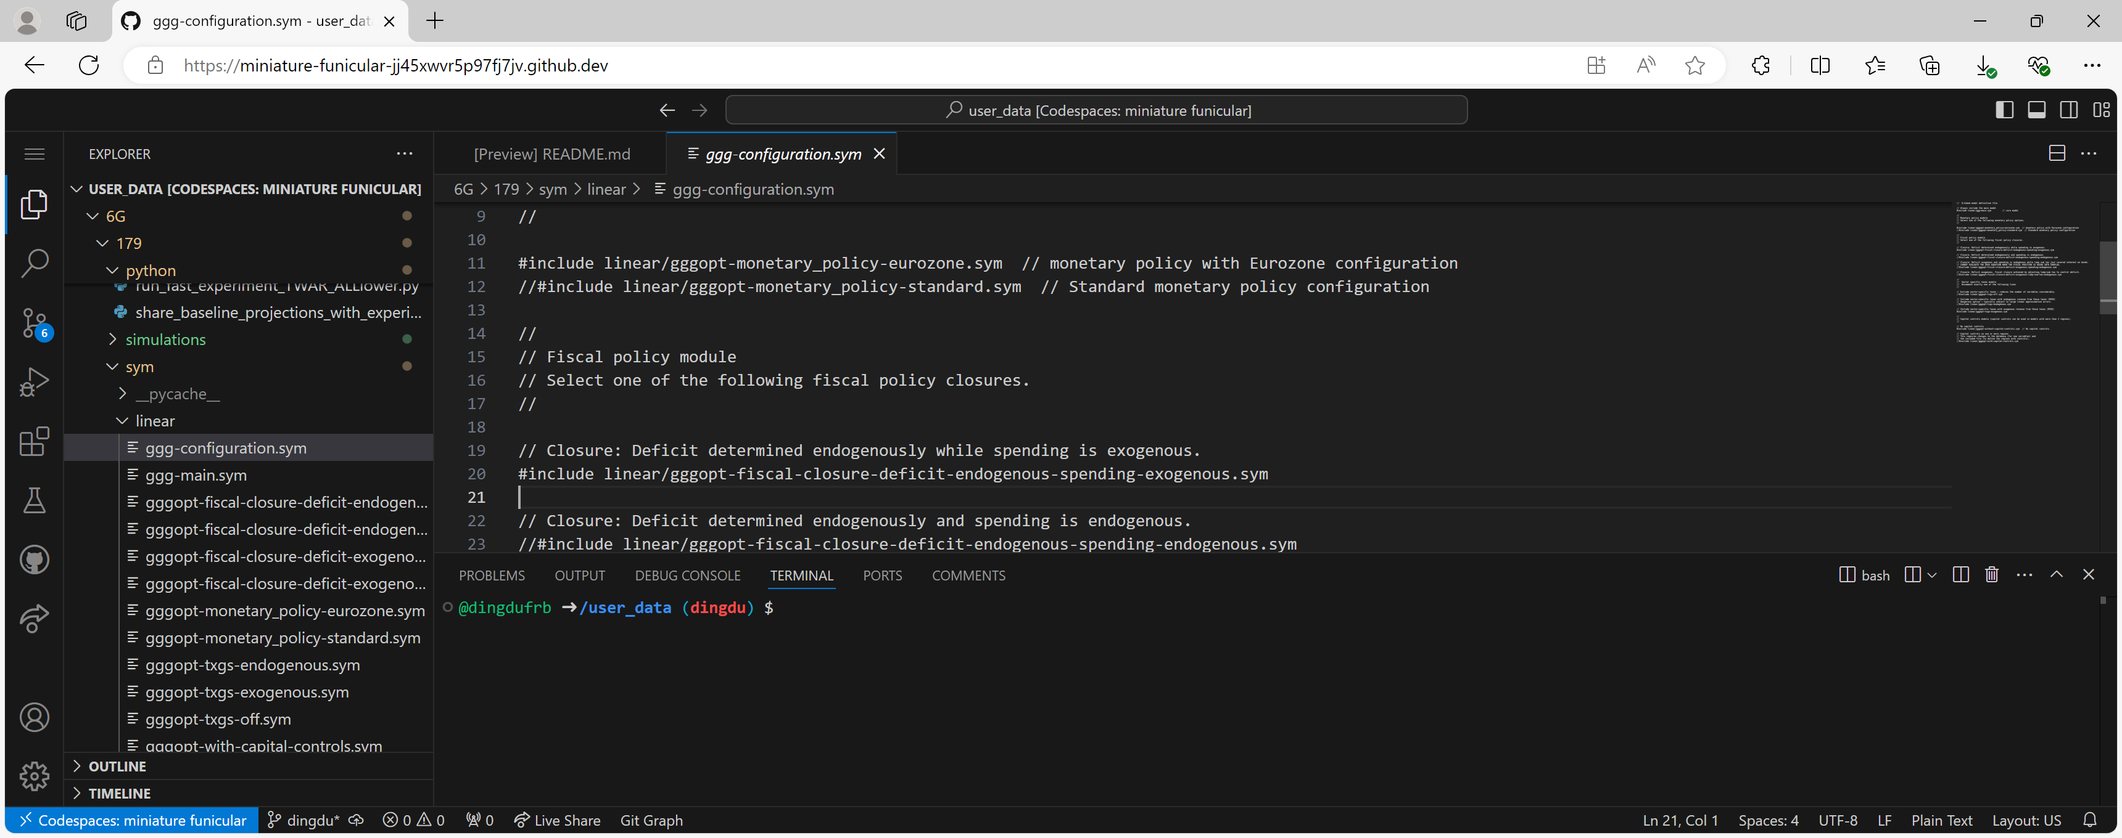

We then process the main sym file and generate HTML documentation of the model with the following commands.

o Change the directory to the “sym” folder with the cd commend.

*cd /user_data/6G/179/sym*

* Process the main sym file with the sym commend.

*sym -python ggg-6G-179.sym model_6G_179.py*

* Generate HTML documentation of the model

*sym -html ggg-6G-179.sym model_6G_179.html*

Download model_6G_179.html by right clicking on the file and then on “Download”.

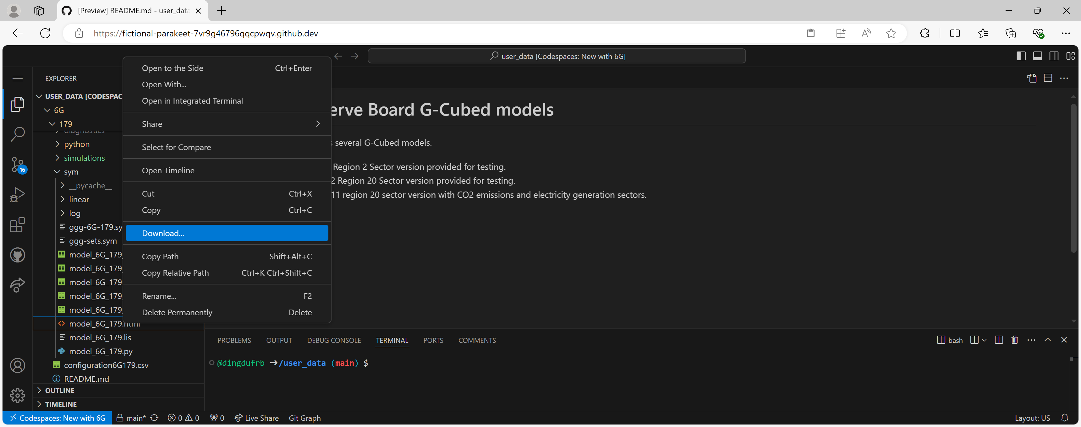

After you download the html file, open it in your browser and search for “tariff”. This will help us identify the variable we need to shock, which is TIM.



The experiment is that US imposes a 60-percentage point tariff increase on all Chinese imports. As such, the variables we will shock are:



where g01 – g06 are six goods in 6G.

1. Specify the baseline - Since we use default baseline shocks and projections (as well as model calibration), we do not need to modify any data files (as well as the model configuration file, configuration6G179.csv)[6].
2. Specify the experiment – We create the design and adjustments files. In the design file, we specify the event year to be 2025. In the adjustments file, we shock TIM by 60 percentage points from 2025 to 2150.

 

Then we create the experiment subfolder “experiment_replication” in the “simulations” folder, and upload the design and adjustments files to the subfolder.

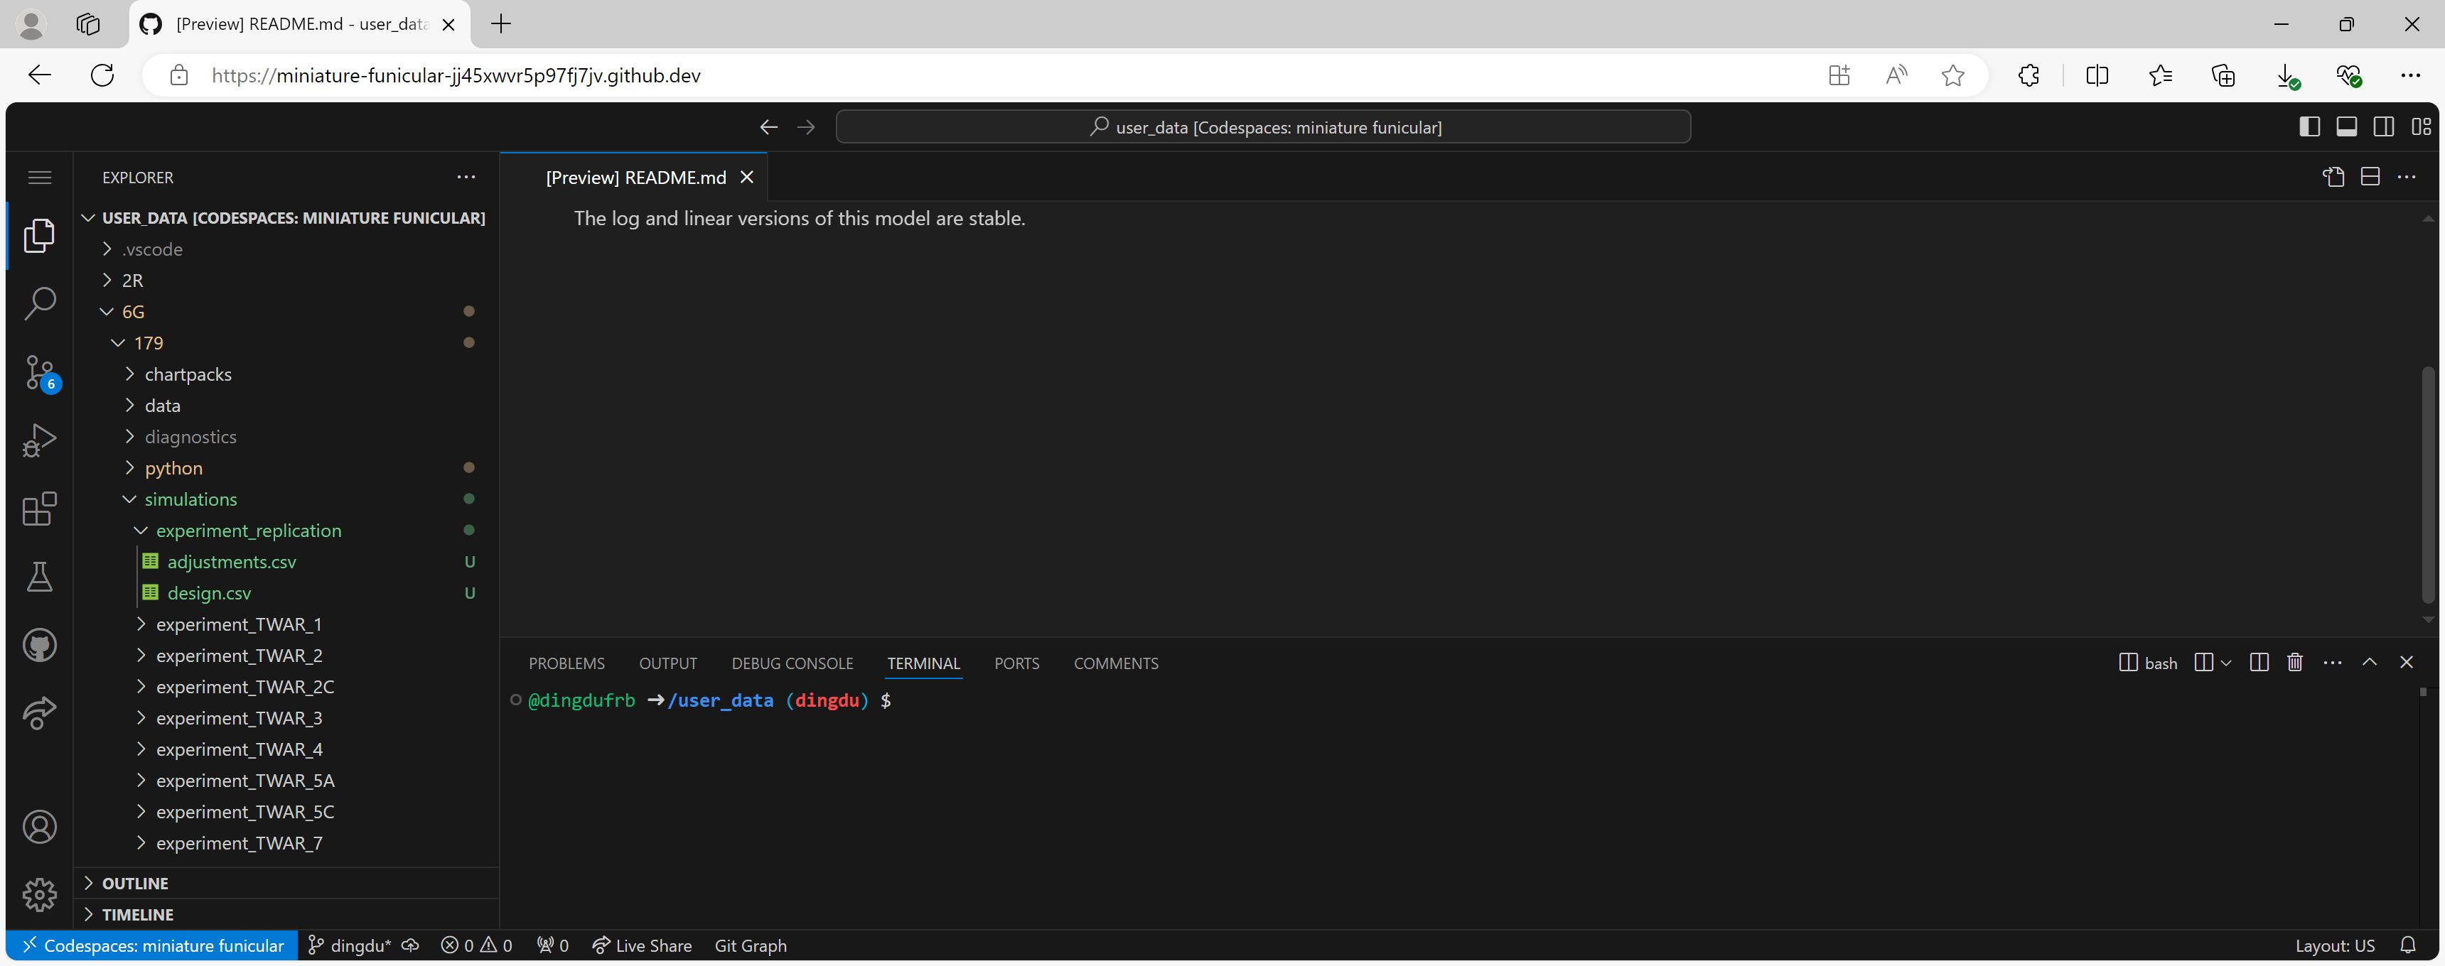

1. Run the experiment
2. We download an example python script and change the experiment name to REPLICATION (see below).

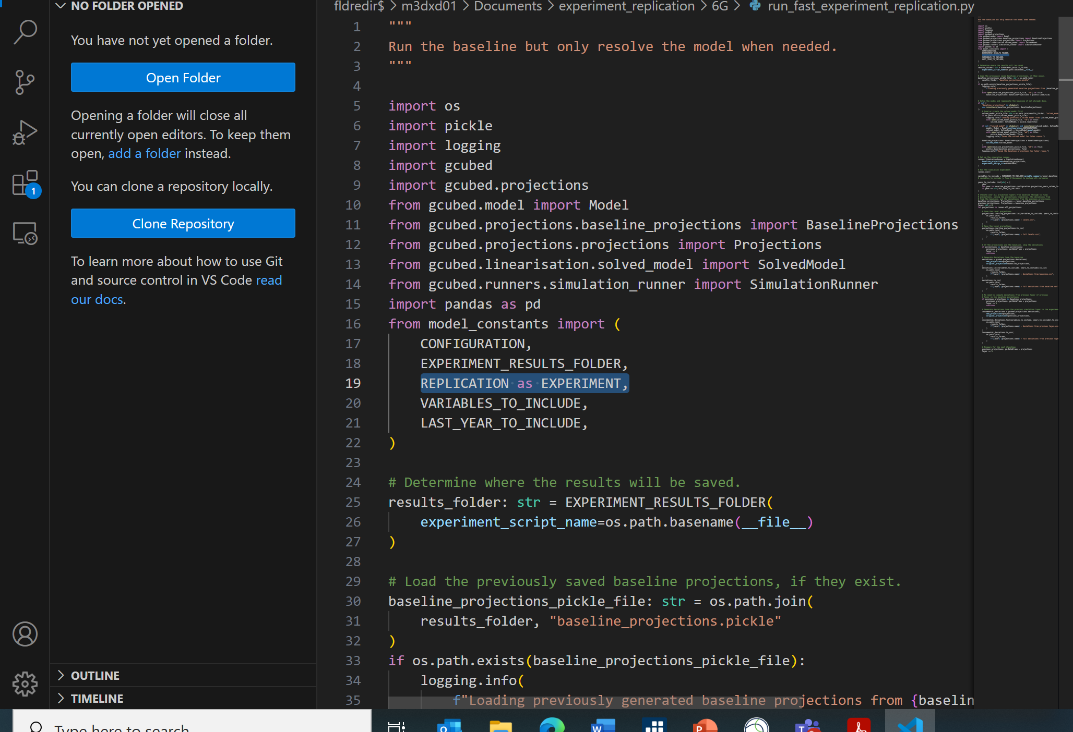

Then we save and name the file as run_experiment_replication.py. A copy of the file is [here](https://spweb.frb.gov/sites/OFS/FSCC/FSCC%20Secretariat/Secretariat_MembersOnly/G-Cubed%20-%20Climate%20Model/Training/Model%20Training%202024/run_fast_experiment_replication.py).

1. We upload the python file to the “python” folder.

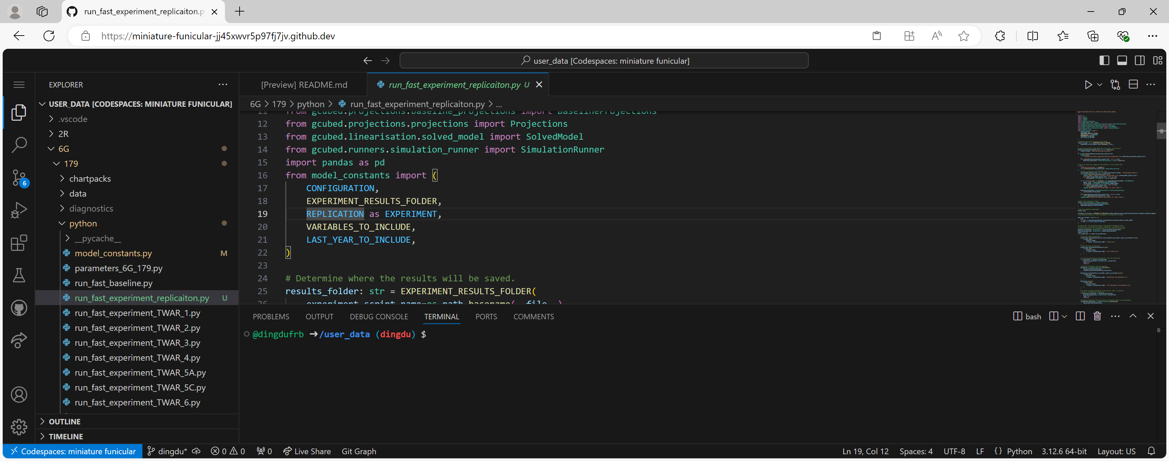

1. We add the following code in model_constants.py to identify the location of the design file for the experiment “REPLICATION”

*REPLICATION: str = "experiment_replication/design.csv"*

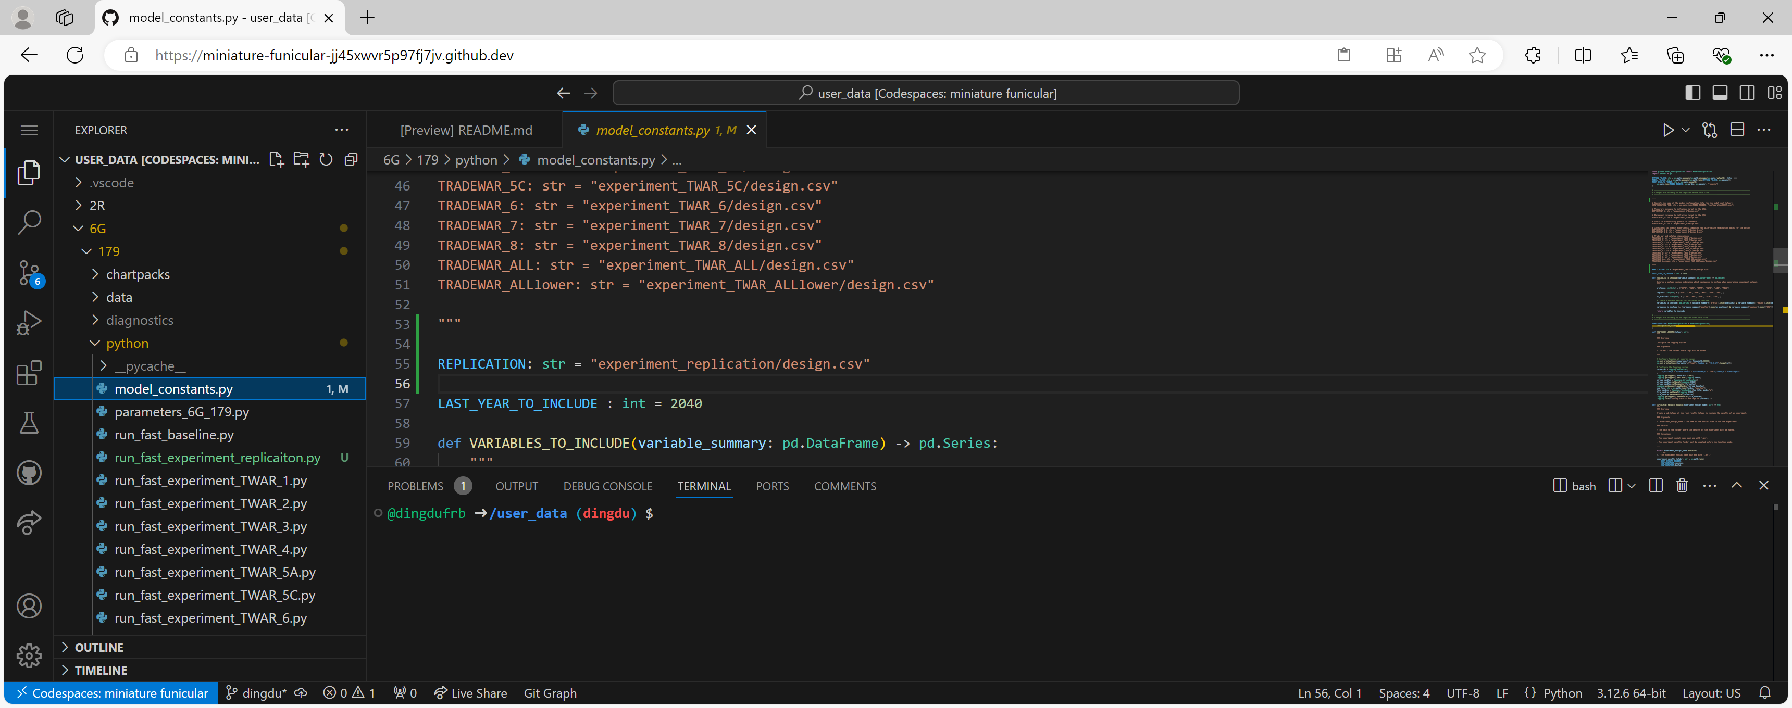

1. We execute the relevant Python scripts in the following order.

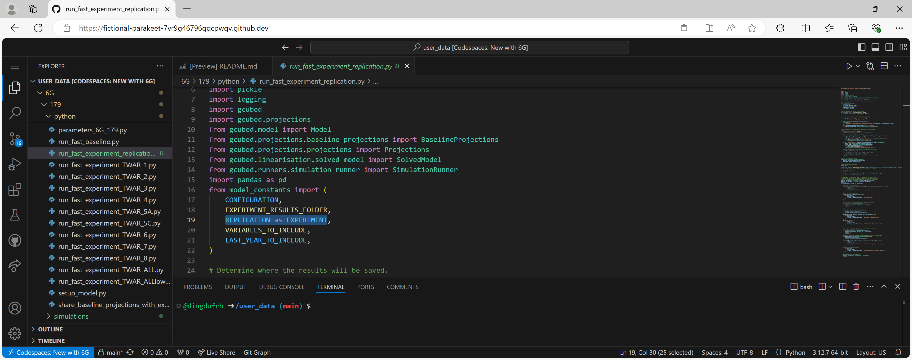

* Step 1, run “run_fast_baseline.py” in the “python” folder. We can run the script by clicking on the small arrowhead pointing to the right in the top right corner of the editor tab (see above). We can also run the script with the following commands in the terminal.
* Enter the “python” folder.

*cd /user_data/6G/179/python*

* Run the script with either “python3” or “python” (which represent different versions of python and should all work).

*python3 run_fast_baseline.py*

* Step 2, run “share_baseline_projections_with_experiments.py” in the “python” folder.

*python3 share_baseline_projections_with_experiments.py*

* Step 3, run “run_experiment_replication.py”.

*python3 run_fast_experiment_replication.py*

**Note again that if only one experiment is being considered (as opposed to multiple experiments), Step 1 and Step 2 above can be skipped, as Step 3 will generate baseline projections if they are not available yet.**

1. Download and graph projections
2. Download “1 China tariff projections from 2025 - full deviations from baseline.csv” from the “results” folder.
3. Download “chartpack_Sim3A_60percenttariffon China.csv” from the “chartpacks” folder.
4. Delete the results folder in Codespace.
5. Upload the downloaded files into the chart application @ <https://documentation.gcubed.com/charts/> for initial inspection.

We can replicate the projections that Warwick presented (see below).

|  |  |
| --- | --- |
| Warwick Projections | Replication Projections |
| Inflation | Inflation |
| Real GDP | Real GDP |

## Appendix A: Summary of the Theoretical Structure of G-Cubed

**Firms**

At the top tier, output is a function of capital, labor, energy and materials:



At the second tier, inputs of energy and materials, *XiE* and *XiM*, are themselves Constant elasticity of substitution (CES) aggregates of goods and services. The goods and services purchased by firms are, in turn, aggregates of imported and domestic commodities which are taken to be imperfect substitutes.

In each sector the capital stock changes according to the rate of fixed capital formation (*Ji)*. and the rate of geometric depreciation (δ*i*):



In order to install *J* units of capital a firm must buy a larger quantity, *I*, which depends on its rate of investment (*J*/*K)*.:



The goal of each firm is to choose its investment and inputs of labor, materials, and energy to maximize intertemporal net-of-tax profits.

where , τ2 is the corporate income tax, τ4 is an investment tax credit, *P*\* is the producer price of the firm’ s output, *R(s)* is the long-term interest rate between periods *t* and *s*, and *n* is the rate of growth of population plus productivity growth.



where λ*i* is the increment to the value of the firm from a unit increase in its investment at time *t*. Investment goods are supplied, in turn, by a seperte industry that combines labor and the outputs of other industries to produce raw capital goods. The investment column of the input/output table is used to to estimate its production parameters.

Carbon dioxide emissions are associated with the usage of fossil fuels in the production process across all sectors. They depend on the scale of output from each sector and the fossil-fuel intensities of each sector.

**Households**

Households have three distinct activities in the model: they supply labor, they save, and they consume goods and services.



The household maximizes utility. subject to the constraint that the present value of consumption be equal to the sum of human wealth, *H*, and initial financial assets, *F*.



Human wealth is defined as the expected present value of the future stream of after-tax labor income plus transfers:



where τ1 is the tax rate on labor income, *TR* is the level of government transfers, *LC* is the quantity of labor used directly in final consumption, *LI* is labor used in producing the investment good, *LG* is government employment, and *Li* is employment in sector *i*. Financial wealth is the sum of real money balances, *MON*/*P*, real government bonds in the hand of the public, *B*, net holding of claims against foreign residents, *A*, the value of capital in each sector, and holdings of emissions permits, *QiP*:



Assuming some consumers (1 – α8) are liquidity-constrained and consume a fixed fraction g of their after-tax income (*INC)*



Once the level of overall consumption has been determined, spending is allocated among goods and services according to a two-tier CES utility function. Household capital services consist of the service flows of consumer durables plus residential housing.

In the long run, labor supply is completely inelastic and is determined by the exogenous rate of population growth.

**Production Function**

There is a production function for each sector within each region. It is based upon nested Constant Elasticity of Substitution (CES) functions. The nesting structure is illustrated in the figure below for all sectors except electricity distribution sector (sector 1). Note that the elasticities of substitution for each CES aggregator, within each sector, are estimated using US data. These elasticities are assumed to be the same across regions but different across sectors.

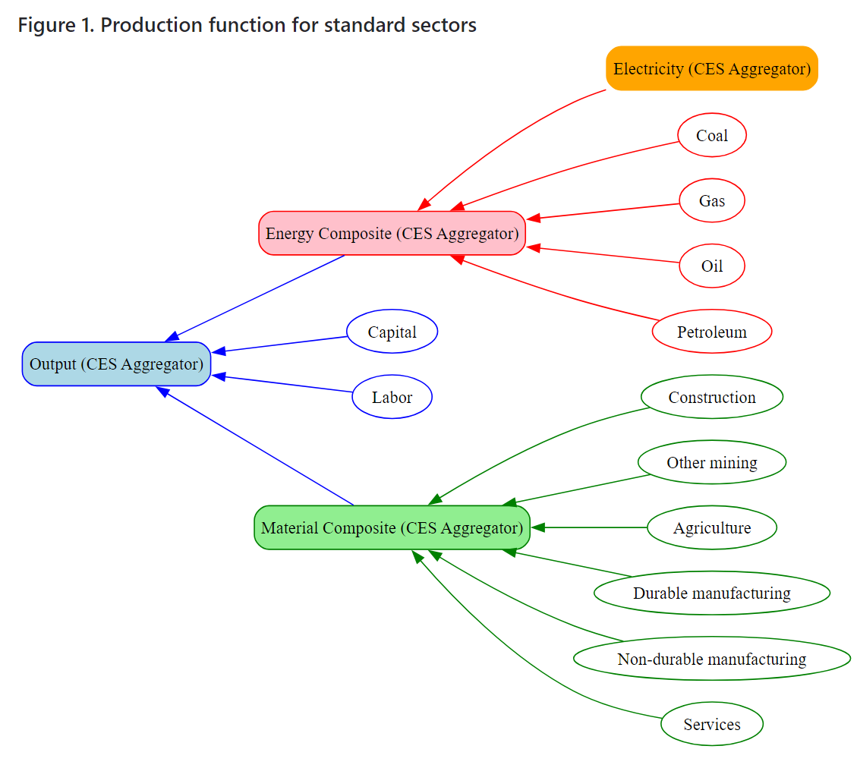

The electricity generation sectors use the standard production technology, described above. The electricity distribution sector has a different production technology that aggregates the electricity produced by electricity generation sectors and distributions that power through the economy. The only inputs to the electricity distribution sector are the electricity generated by the domestic electricity generation sectors. There is no capital or labor or other materials used in the sector.

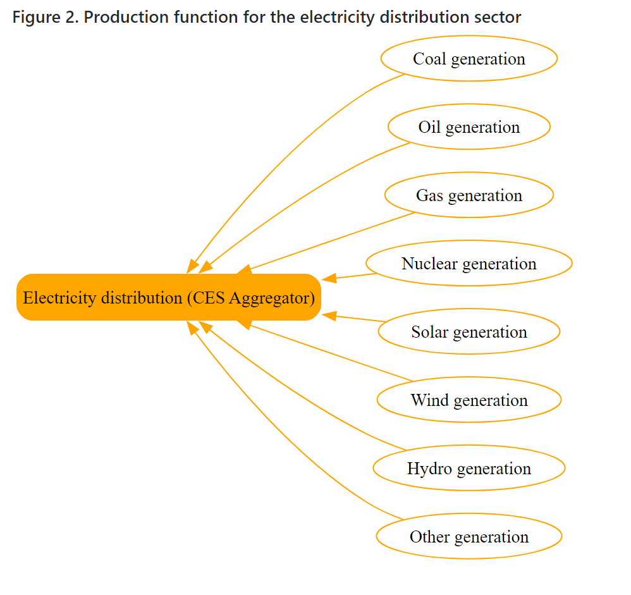

The figure below visualizes this tier-structured constant elasticity of substitution (CES) function.



All G-Cubed models have two additional sectors built into them:

* Y The sector that produces capital for firms
* Z The sector that produces capital for households

Care needs to be taken because these two capital-producing sectors are not explicitly included in the sectors set of G-Cubed models.

## Appendix B: Regions, Sectors, and Variable Units

In 20C/179 of G-Cubed, the regions are:

1. United States (USA)
2. Japan (JPN)
3. Australia (AUS)
4. Europe (EUR)
5. Canada (CAN)
6. China (CHN)
7. India (IND)
8. Rest of the OECD (ADV)
9. Rest of World (ROW)
10. Russian Federation (RUS)
11. Oil-Exporting developing countries (OIL)

Each region aggregates production into the same 20 sectors:

1. Electricity distribution
2. Gas extraction and utilities
3. Petroleum refining
4. Coal mining
5. Crude oil extraction
6. Construction
7. Other mining
8. Agriculture and forestry
9. Durable goods
10. Nondurable goods
11. Transportation
12. Services
13. Coal generation of electricity
14. Natural gas generation of electricity
15. Petroleum generation of electricity
16. Nuclear generation of electricity
17. Wind generation of electricity
18. Solar generation of electricity
19. Hydroelectric generation of electricity
20. Other generation of electricity

Variable units

* idx - index (100 in base year in the database)
* rate - percentage (e.g. tax rate)
* del - percentage points (e.g. shock to target inflation rate)
* pct – for variables measured as a percentage
* gdp – normalized by local gdp (numerator and denominator both expressed in USD)
* usgdp – normalized by US gdp (numerator and denominator both expressed in USD)
* dollar – US dollars (e.g. dollar tax on Carbon emissions)
* btu – quadrillion btu
* mmt – million metric tons
* gwh – Gigawatt hours
* btugdp – btu normalized by local gdp valued in USD
* mmtgdp – mmt normalized by local gdp valued in USD
* gwhgdp – Gigawatt hours normalized by local gdp valued in USD
* btuusgdp – btu normalized by US gdp valued in USD
* mmtusgdp – mmt normalized by US gdp valued in USD
* nomusdbillion – nominal USD billion
* realusdbillion – real USD billion

## Appendix C: Linear/Log Version, Fiscal Policy Module, and Sector specific taxes module

**Linear Version**

//=====================================================================

//

// Demand for each composite good

//

//=====================================================================

goods_e : OUY = CON + IIN + INS + GCE + EXQ + sum(sec_std,EN) ;

goods_mc: OUY = CON + IIN + INS + GCE + EXQ + sum(sec_std,OI) ;

good_durable_manufacturing: OUY = IIN + INS + GCE + EXQ + sum(sec_std,OI) ;

**Log Version**

//=====================================================================

//

// Demand for each composite good

//

//=====================================================================

goods_e : OUY = ln( exp(CON) + exp(IIN) + INS + exp(GCE) + exp(EXQ) + sum(sec_std,exp(EN)) ) ;

goods_mc: OUY = ln( exp(CON) + exp(IIN) + INS + exp(GCE) + exp(EXQ) + sum(sec_std,exp(OI)) ) ;

good_durable_manufacturing: OUY = ln( exp(IIN) + INS + exp(GCE) + exp(EXQ) + sum(sec_std,exp(OI)) ) ;

**Fiscal Closures**

The following approaches are available as alternative treatments that all provide ‘fiscal closure’. They are modules that should be turned on/off by appropriately commenting out all but the required module in the relevant ggg-configuration.sym file, located in the linear/log subfolder of the model’s sym folder. Make changes to the appropriate configuration depending on the functional form being used.

1. Deficit determined endogenously and spending is endogenous - Use this module in experiments where you want to exogenously determine government spending on the **goods produced by one or more sectors**. All other aspects of government behaviour are endogenous and achieve fiscal closure.

*variable GOVS(regions) 'government spending excluding labor' end,gdp ;*

*variable GCE(goods_o,regions) 'government purchases of goods and services' exo,gdp ;*

*GCET = sum(goods_o,GCE*exp(PRY(goods_o))) / exp(PRID) ;*

*GOVS = GCET;*

1. Deficit determined endogenously while spending is exogenous - Use this module in experiments where you want to exogenously determine **total government spending**. A simple rule then allocates that spending across the goods produced by each sector. All other aspects of government behaviour are endogenous and achieve fiscal closure.

*variable GOVS(regions) 'government spending excluding labor' exo,gdp ;*

*variable GCE(goods_o,regions) 'government purchases of goods and services' end,gdp ;*

*goods_e: GCE = delta_eG*(delta_oG(e)/(delta_oG(e)+delta_oG(m))) * GOVS * exp(PRID) / exp(PRY) ;*

*goods_m: GCE = delta_mG*(delta_oG(m)/(delta_oG(e)+delta_oG(m))) * GOVS * exp(PRID) / exp(PRY) ;*

1. Deficit exogenous, fiscal closure achieved by adjusting lump-sum tax to control deficit – The government deficit **and total government spending are determined exogenously**. **The fiscal deficit, DEFI is controlled** by adjusting the lump sum tax, TAXS, as necessary.

*variable GOVS(regions) 'government spending excluding labor' exo,gdp ;*

*variable GCE(goods_o,regions) 'government purchases of goods and services' end,gdp ;*

*goods_e: GCE = delta_eG*(delta_oG(e)/(delta_oG(e)+delta_oG(m))) * GOVS * exp(PRID) / exp(PRY) ;*

*goods_m: GCE = delta_mG*(delta_oG(m)/(delta_oG(e)+delta_oG(m))) * GOVS * exp(PRID) / exp(PRY) ;*

*// The lump sum tax is to hold the deficit equal to DEFX - TAXS*

*TAXL = GOVT + TRAN - (TAXC + TAXH + TAXM + TAXX + TAXE) + INTR*BOND - DEFI + TAXS ;*

1. Deficit exogenous and spending is endogenous while lump sum tax just covered interest on bonds - The deficit is of the consequences of tax and spending decisions showing up in a lump-sum tax.

*variable GOVS(regions) 'government spending excluding labor' end,gdp ;*

*variable GCE(goods_o,regions) 'government purchases of goods and services' end,gdp ;*

*// Government spending excluding labor set to allow deficit to be determined exogenously.*

*GOVS = DEFI - GOVL*exp(WAGG-PRID) - TRAN + TAXT - INTR*BOND ;*

*goods_e: GCE = delta_eG*(delta_oG(e)/(delta_oG(e)+delta_oG(m))) * GOVS * exp(PRID) / exp(PRY) ;*

*goods_m: GCE = delta_mG*(delta_oG(m)/(delta_oG(e)+delta_oG(m))) * GOVS * exp(PRID) / exp(PRY) ;*

*// The lump sum tax is equal to the debt servicing costs plus and exogenous adjustment.*

*TAXL = INTR*BOND + TAXS ;*

**Sector Specific Taxes Module**

* 1. Exclude sector-specific taxes - reduces the number of variables considerably. If this module is used, remove the TXGS, RVGS and PRT variables from the database.
  2. Include sector-specific taxes with endogenous revenue from those taxes (RVGS), which can be subject to large linear approximation errors.

*variable RVGS(regions) 'revenue from unit taxes' end,gdp ;*

*RVGS = sum(goods_e, sum(sec_std,(EN * (TXGS + TCPS*co2coef/100)) + FDEN*TCPSFD*co2coef/100)) / exp(PRID) ;*

* 1. Include sector-specific taxes with exogenous revenue from those taxes (RVGS), which must be set via a shock file. This is similar to exogenous treatment of the TAXE variable.

*variable RVGS(regions) 'revenue from unit taxes' exo,gdp ;*

## Appendix D: SALT Environment

The previous build, 178, can also be ran in SALT. This appendix provides instructions for running G-Cubed models in SALT.

***Download G-Cubed***

1. Launch SALT.
2. Type “salt” in the search box, and press Enter.
3. Right click and click “terminal”, and a console will appear.
4. Copy the gcubed model to the directory of your choosing. If you have a project or research directory for each person that will run this model, you can copy it there. This will take several minutes.

*rsync -av --exclude=.git /sftwr/apps/gcubed /path/to/project/directory/*

If the directory is /ofs/home/m3dxd01,

*rsync -av --exclude=.git /sftwr/apps/gcubed /ofs/home/m3dxd01/*

***Active G-Cubed***

1. Run a bash shell

*bash*

1. Activate the G-cubed virtual environment

*source /path/to/project/directory/gcubed/.venv/bin/activate*

If the directory is /ofs/home/m3dxd01,

*source /ofs/home/m3dxd01/gcubed/.venv/bin/activate*

***Run experiments***

This is running the 2R/178 model.

1. Define model version

*cd  ~/gcubed/user_data/2R/178/sym/*

*sym -python ggg-2R-178.sym model_2R_178.py*

1. Create simulation data files.
2. Create and modify relevant python scripts.
3. Execute python scripts

python /path/to/project/directory/gcubed/user_data/2R/178/python/python script

If the directory is /ofs/home/m3dxd01,

*python /ofs/home/m3dxd01/gcubed/user_data/2R/178/python/run_fast_baseline.py*

*python /ofs/home/m3dxd01/gcubed/user_data/2R/178/python/share_baseline_projections_with_experiments.py*

*python /ofs/home/m3dxd01/gcubed/user_data/2R/178/python/run_fast_experiment_1.py*

1. Experiment results are located in /path/to/project/directory/user_data/results/<model>/<build>/<experiment>/

If the directory is /ofs/home/m3dxd01 and the model version is 2R/178, the results are in

/ofs/home/m3dxd01/user_data/results/2R/178

## Appendix E: Useful Script

One of the TA’s working on G-Cubed, Charles Knipp, had made a shell on his branch of G-Cubed that helped automate some repetitive commands when working with the model on a regular basis. The script he wrote to do this is in his branch of G-Cubed in a README: [McKibbin-Software-Group/federalreserve.gov-0.1-model at m1cak00 (github.com)](https://github.com/McKibbin-Software-Group/federalreserve.gov-0.1-model/tree/m1cak00). If you have questions reach out to him at [Charles.A.Knipp@frb.gov](mailto:Charles.A.Knipp@frb.gov).

  

 

1. For a summary of the theoretical structure of the G-Cubed model, please refer to Appendix A.
2. For regions, sectors, and variable units in 20C, please refer to Appendix B.
3. For more details about the linear vs. log version as well as different fiscal policy options, please see Appendix C.
4. The baseline projections are modified using adjustments to exogenous variables in the model. The adjustments that are applied when generating the baseline projections must be specified in a design file. The model configuration file, <CONFIGURATION>.csv specifies the name of the design file that is used to generate the baseline projections as the value of the BaselineDesignFile setting. *If that setting is included in the model configuration, then the named design file (e.g., baseline_design.csv) must be in the “data” directory of the model.* If the BaselineDesignFile setting is missing from the model configuration file, there will be no adjustments to exogenous variables when generating the baseline projections (i.e., productivity and population growth rates will be zero in the baseline projections). Note that all of the baseline simulation layers must have the same event year and that event year must be the first projection year. Typically, the baseline design file references just one simulation layer adjustment file (e.g., baseline_exogenous_projections.csv).
5. Typically, experiments are run using [a Runner object](https://documentation.gcubed.com/api/gcubed/runners.html). There are a number of Runner classes. They run the experiment and save the results to the “results” folder. A Runner will run an entire experiment, using a model solution and building on a set of baseline projections by sequentially applying the sequence of simulation layers to those baseline projections.

   The projections associated with the application of each simulation layer are preserved as [a Projections object](https://documentation.gcubed.com/api/gcubed/projections/projections.html). To access the full list of projections produced when running an experiment, access the Runner.all_projections property. Each Projections object provides access to the projections implied by the baseline and the cumulative impact of the simulation layers up to and including its own simulation layer. In this way, the Runner object provides a way to analyze the marginal and cumulative impacts of each simulation layer. To assess the marginal impact of a simulation layer, work with deviations of the simulation layer’s projections from the projections associated with the previous simulation layer. To assess the cumulative impact of all simulation layers up to and including the simulation layer of interest, work with deviations of that simulation layer’s projections from the baseline projections.
6. The model configuration file contains all of the information needed to load a specific model (e.g., data and sym files). It must be in the root directory. *Note that the model version and the model build values used in file naming must match their values in the model configuration file*.